SPRINT -3

|  |  |
| --- | --- |
| Date | 12 November 2022 |
| Team id | PNT2022TMID11798 |
| Project name | Real Time River Water Quality Monitoring And  Control System |
| Maximum marks | 20 marks |

Designing the mobile application using mit app inventor

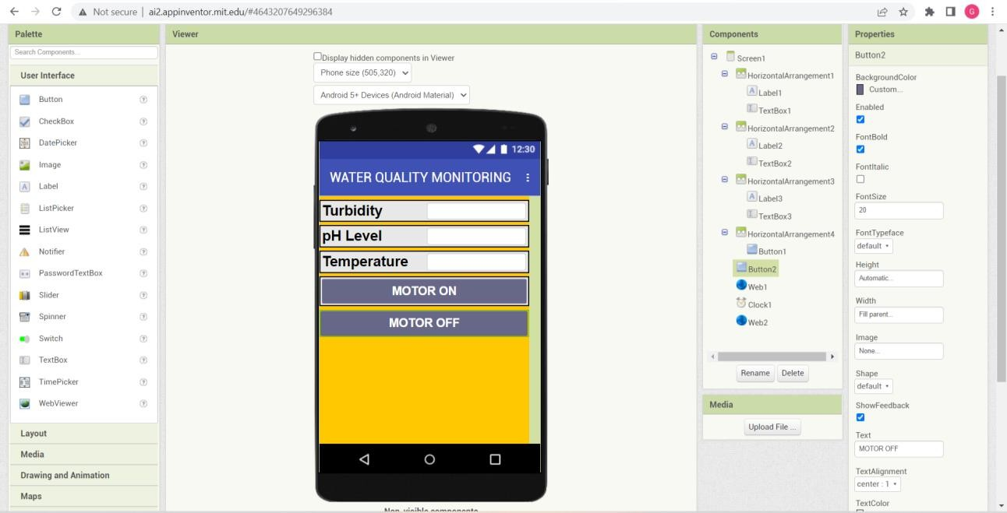

FUNCTIONAL BLOCKS

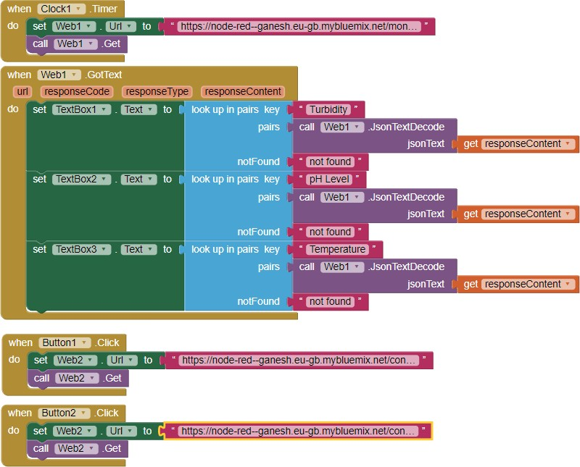

NODE-RED FLOWS :

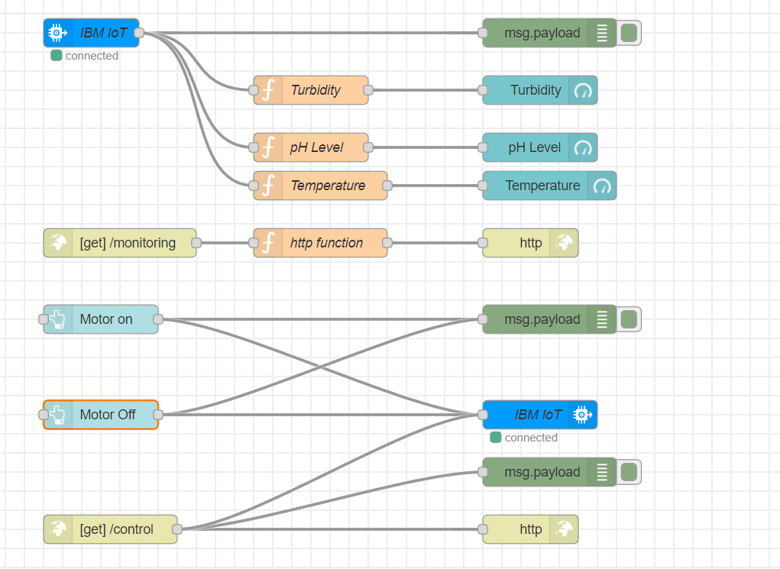

MOBILE APPLICATION :

